Shinas College of Technology





SULTANATE OF OMAN

INFORMATION TECHNOLOGY DEPARTMENT

Mini-Project

(To cover the outcomes by *Self-reliant, Student Centered Learning Approach*)

|  |  |  |  |
| --- | --- | --- | --- |
| Level: | BTech | Specialization: | Networking |

|  |  |  |  |
| --- | --- | --- | --- |
| Course Code: | ITNT4102 | Course Name: | Adhoc Wireless Network |

|  |  |  |  |
| --- | --- | --- | --- |
| Date of Issue: | May 4, 2016 | Date of Submission: | June 9, 2016 |

|  |  |
| --- | --- |
| Assignment Number and Title: | #1-Mini Project |

|  |  |
| --- | --- |
| Group: | 1 |

**Instructions:**

1. E-mail your assignment to [bernard.agbuya@shct.edu.om](mailto:bernard.agbuya@shct.edu.om). No hardcopy, or softcopy from USB is accepted for security purposes.
2. After sending your assignment, secure the copy of the sent mail (see *Sent Items*) as evidence until you get the confirmation of receiving from your course lecturer. If you don’t get any confirmation in one (1) or two(2) days, send it again and follow-up personally.
3. No updated versions are accepted once the assignment is submitted.
4. Write your ID, Course Title, and Section in the Subject of your mail.

(Example: *S01234_Adhoc_1*)

1. Use only your college mail to send your work. Contact ETC in case you have a log-in problem.
2. Marks will be deducted for late submission. Twenty percent (20%) of the assignment scored mark will be reduced for each day of late submission.
3. Plagiarism is a crime. Plagiarism occurs when other’s work such as print material, images, audio-visual creations, computer programs, electronic materials, etc. are used without appropriate acknowledgement and this can be checked by copying your work to any search engines.

Plagiarism includes, but not limited to the following:

## Copying full or part (paragraphs, sentences or significant part of a sentence) of other’s work directly

## Copying from other’s work with an end reference to the original source but without putting the copied text between quotation marks

## Paraphrasing, summarizing, or rearranging words, phrases or ideas of other’s work

## Copy-Paste of statements from multiple sources (electronic or print material)

## Presenting work done in collaboration with others as independent work

## Using one’s own work presented previously

## Disciplinary Action for Student Plagiarism (for ALL involved) is Zero mark.

To avoid plagiarism, you must give credit whenever you use:

1. another person’s idea or theory;
2. any piece of information which is not a common knowledge; *and*
3. material from a website.

*A student who satisfactorily completes the assignment should be able to:*

|  |  |
| --- | --- |
| Learning Objective | Course Outcome No. |
| 1. **VLANs and VTP** | 1-3 |
| 1. **Inter-VLAN and DHCP** | 1-3 |
| 1. **Wireless Connectivity using the Router 819 Series in B1-Branch** | 1-3 |
| 1. **WAN Technologies- Routing and Frame-Relay** | 4-5 |
| 1. **Troubleshooting-Wireless Connectivity using Radius Server** | 6 |

--------------------------------------------------------------------------------------------------------------------------------------------

**Scenario-based Problem:**

The University of Technology and Applied Sciences Shinas is planning to upgrade their wireless networks by installing new wireless router and access points. The SunTechnos was commissioned to implement the proposed project based on the logical topology provided.

**Network Topology**

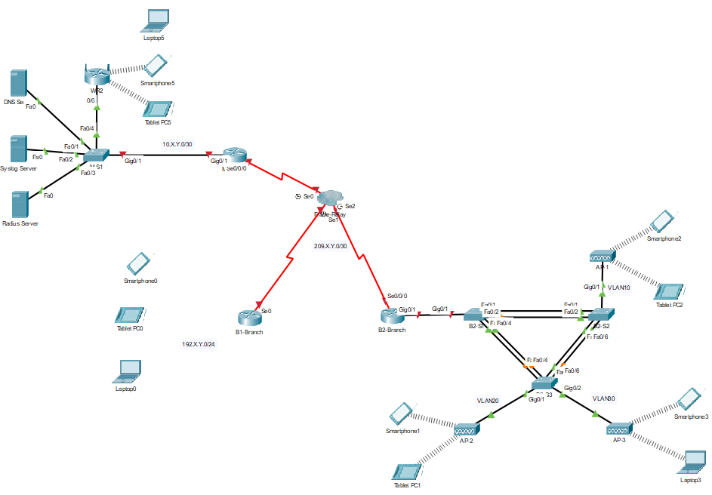

1. Where:
2. X = first 2 digit of your student number after J or S
3. Y= last 2 digit of your student number after J or S

Example: 66J1148 --------- (X=11) and (Y=48)

**Requirements**

1. **VLANs and VTP**
   1. Configure the VLANs and VTP in B2-Branch as indicated below:

**B2-BRANCH VLAN Details:**

|  |  |  |
| --- | --- | --- |
| **VLAN Number** | **VLAN Name** | **Network** |
| VLAN10 | Admin | 172.X.Y.128/25 |
| VLAN20 | HR | 172.X.Y.192/26 |
| VLAN30 | Finance | 172.X.Y.224/27 |
| VLAN44 | Native/Management | 172.X.Y.240/28 |

**B2-BRANCH VTP Details:**

|  |  |  |  |
| --- | --- | --- | --- |
| **Device** | **VTP Mode** | **Domain** | **Password** |
| B2-S1 | Server | Your-name | Your-id |
| B2-S2 | Client | Your-name | Your-id |
| B2-S3 | Client | Your-name | Your-id |

* 1. Configure the trunk and access ports of all switches.
  2. Configure the SVI with default gateway of each switch as indicated in the given network.

1. **Inter-VLAN and DHCP**
   1. Configure the B2-Branch as DHCP server.
   2. Configure the sub-interfaces for inter-VLAN routing on B2-Branch.
   3. Configure the DHCP service for each VLAN.
   4. Configure all the basic setting with SSID to be broadcast on AP1 and AP2. SSID to be unbroadcast on AP3.
   5. Connect all wireless devices to specifis access point.
2. **Wireless Connectivity using the Router 819 Series in B1-Branch.**
   1. Configure the **B1-Branch** with wireless connectivity.
   2. Connect all wireless devices to this router.
3. **WAN Technologies- Routing and Frame-Relay**
   1. Configure OSPF as routing protocol connecting M-Branch, B1-Branch and B2-Branch.
   2. Configure the frame-relay encapsulation using static mapping based on the addresses on the topology.
   3. Configure the frame-relay cloud for connectivity.

1. **Troubleshooting-Wireless Connectivity using Radius Server**
   1. Configure all the IP addresses of the servers based on the network address on the topology.
   2. Troubleshoot W**R2** for wireless connectivity using radius server authentication.
   3. All wireless devices should be connected to WR2.

**Rubrics:**

|  |  |  |
| --- | --- | --- |
| No. | Criteria | Marks |
| 1 | **VLANs and VTP** | **2.0** |
| 2 | **Inter-VLAN and DHCP** | **2.0** |
| 3 | **Wireless Connectivity using the Router 819 Series in B1-Branch** | **1.0** |
| 4 | **WAN Technologies- Routing and Frame-Relay** | **3.0** |
| 5 | **Troubleshooting-Wireless Connectivity using Radius Server** | **2.0** |
|  | TOTAL | **10.0** |

**Sources of Information/References:**

1. CISCO Networking Academy.2014. Connecting Networks Companion Guides – Published May 2, 2014. CISCO Press.
2. Routing and Switching: Scaling Networks Instructor Packet Lab Manual - Published Feb 18, 2014 by [Cisco Press](http://www.ciscopress.com/)
3. LAN Switching and Wireless Companion Guide-Published September 18, 2009 by [Cisco Press](http://www.ciscopress.com/)
4. CCNP SWITCH Companion Guide-Published February 09, 2010 by [Cisco Press](http://www.ciscopress.com/)
5. www.netacad.com

Prepared by: Evaluated by:

Bernard Castro Agbuya Ms. Salama Said Al-Kalbani

*Course Coordinator HOS, Networking*